Downloaded the following datasets from the DRMS website on 3/15/2022:

* Active Coal Permits
* Active Hard Rock Permits
* Active Construction Permits

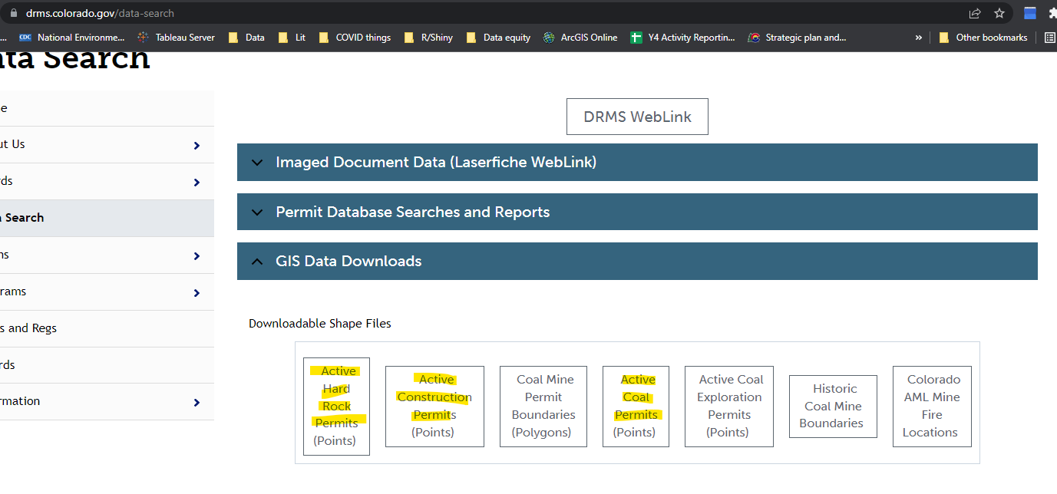

The final layer keeps all points where StatusDesc = “Active” and stacks each dataset.